|  |
| --- |
| **HIRALAL BHAKAT COLLEGE**  NALHATI,BIRBHUM  DEPARTMENT OF  POLITICAL SCIENCE (HONS)  SYLLABUS DISTRIBUTION  UNDER **CBCS PATTERN**  2021-22 |

**B.A POLITICAL SCIENCE (HONS)**

**SEMESTER: II**

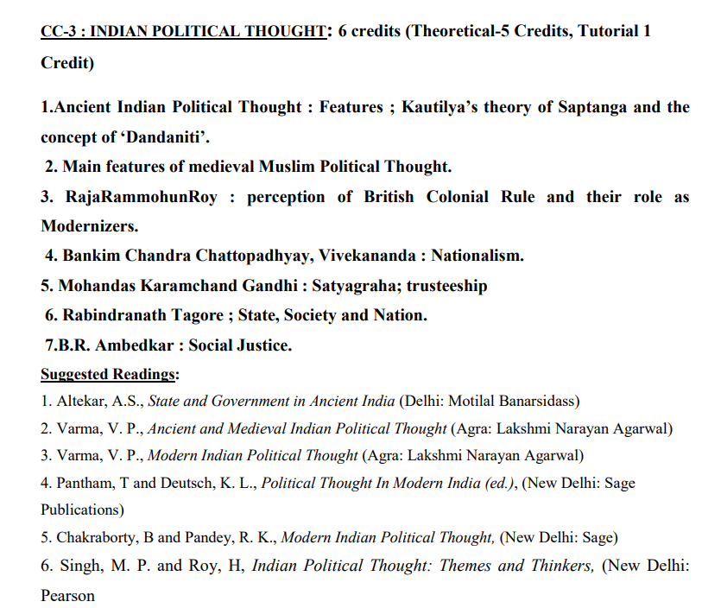

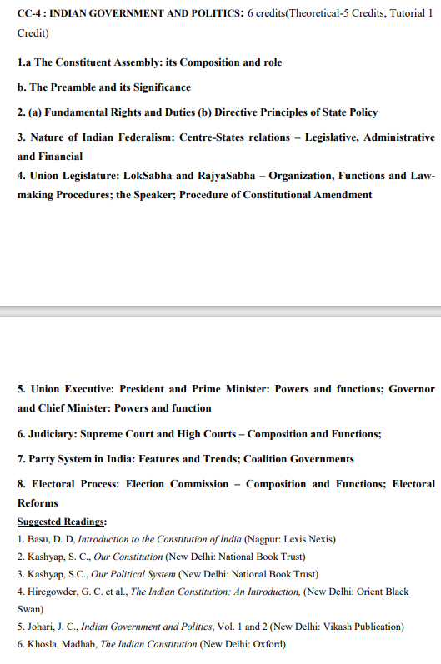

1. Ancient Indian Political Thought: Features; Kautilya’s theory of Saptanga and the concept of ‘Dandaniti’. 2. Main features of medieval Muslim Political Thought. 3. RajaRammohunRoy: perception of British Colonial Rule and their role as Modernizers. 4. Bankim Chandra Chattopadhyay, Vivekananda : Nationalism. 5. Mohandas Karamchand Gandhi: Satyagraha; trusteeship. 6. Rabindranath Tagore; State, Society, and Nation. 7.B.R. Ambedkar: Social Justice.

|  |  |  |
| --- | --- | --- |
| PAPER | NAME OF THE TEACHER | TOPICS |
| CC-3-(Indian Political Thought) | FU | MODULE-1 |
| 1. Ancient Indian Political Thought: Features; Kautilya’s theory of Saptanga and the concept of ‘Dandaniti’.  2. Main features of medieval Muslim Political Thought. |
| BS | MODULE-2 |
| 3. Raja Rammohun Roy: perception of British Colonial Rule and their role as Modernizers.  4.BankimChandraChattopadhyay,Vivekananda: Nationalism.  5. Mohandas Karamchand Gandhi: Satyagraha; trusteeship  6. Rabindranath Tagore; State, Society and Nation.  7. B.R. Ambedkar: Social Justice. |
| PAPER | NAME OF THE TEACHER | TOPICS |
| CC-4 (Indian government and politics) | RN | MODULE-3 |
| 1. a The Constituent Assembly: its Composition and role  b. The Preamble and its Significance  2. (a) Fundamental Rights and Duties (b) Directive  Principles of State Policy |
| NM | MODULE-4 |
| 3. Nature of Indian Federalism: Centre-States relations – Legislative, Administrative  and Financial  4. Union Legislature: LokSabha and RajyaSabha – Organization, Functions and Lawmaking Procedures; the Speaker; Procedure of Constitutional Amendment. |
| SMZ | MODULE-5 |
| 5. Union Executive: President and Prime Minister: Powers and functions; Governor  and Chief Minister: Powers and function  6. Judiciary: Supreme Court and High Courts – Composition and Functions;  7. Party System in India: Features and Trends; Coalition Governments  8. Electoral Process: Election Commission – Composition and Functions; Electoral  Reforms |
| PAPER | NAME OF THE TEACHER | TOPICS |
| GE-2 (Political Theory) | FU | MODULE-6 |
| The Meaning of Politics and Political Theory; Importance of Political Theory; Different Approaches: (a) Traditional (b) Behavioural and Post-Behavioural (c)  Marxist  2. The Concept of Sovereignty: (a) Monistic (b) Pluralist (c) Popular  3. Liberty and Equality: Meaning and their Inter-relationship  4. Liberalism and Neo-Liberalism  5. Theories of State: (a) Idealist (b) Liberal (c) Marxist (d) Gandhian  6. Political parties and pressure groups: concept and role |

**B.A POLITICAL SCIENCE (HONS)**

**SEMESTER-IV**

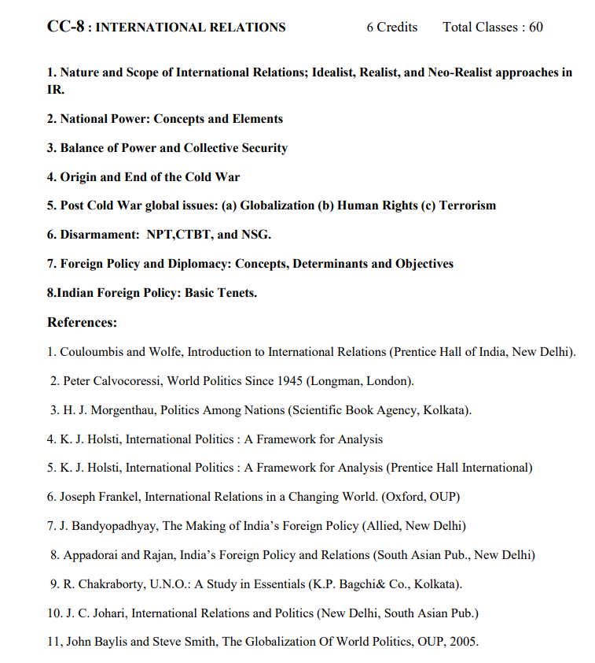

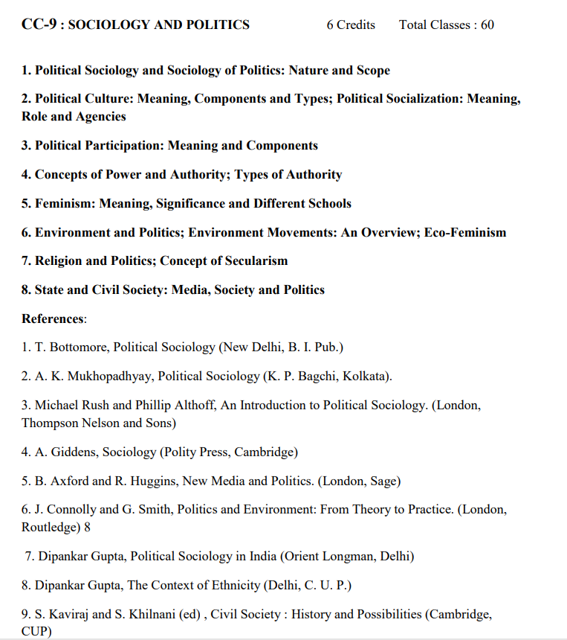

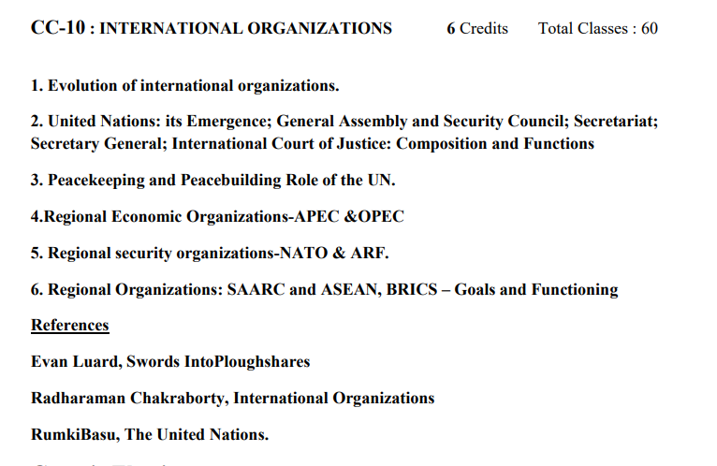

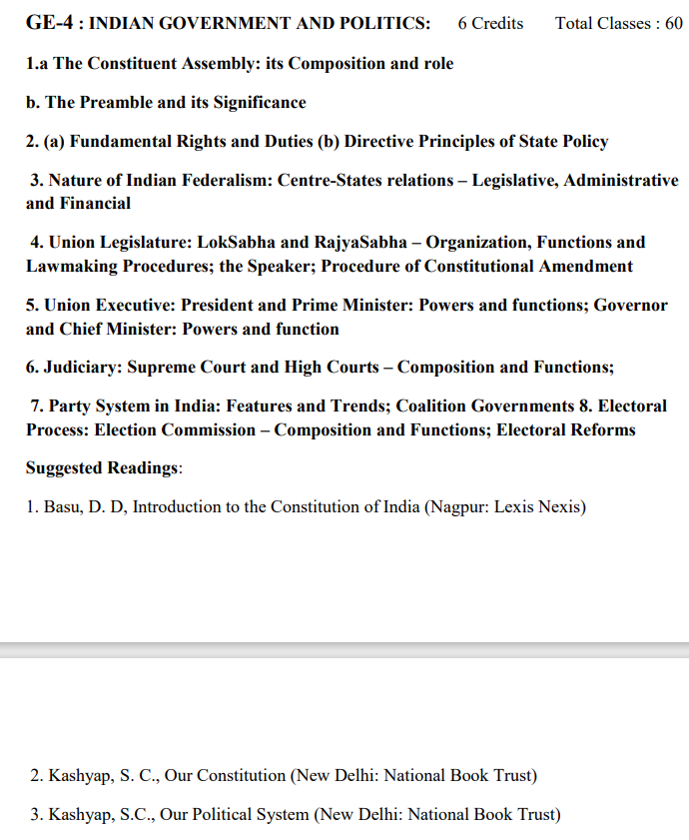

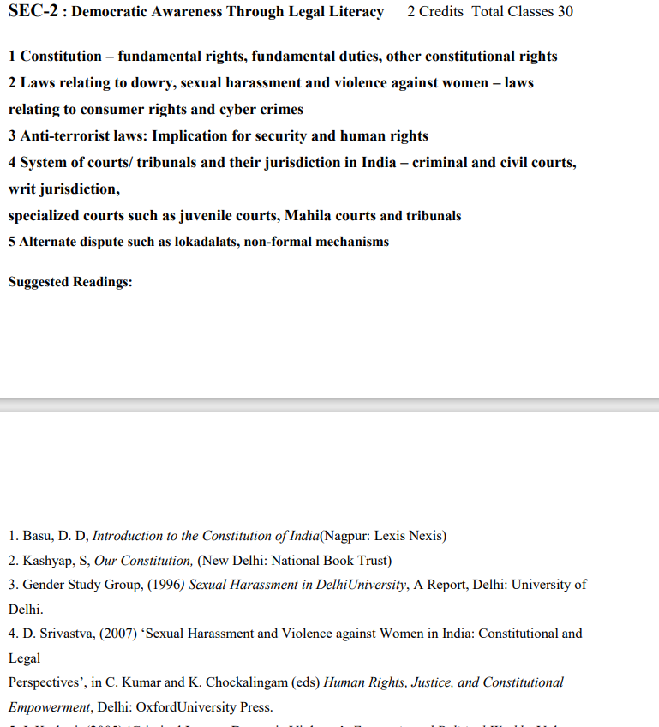

1. Nature and Scope of International Relations; Idealist, Realist, and Neo-Realist approaches in IR. 2. National Power: Concepts and Elements 3. Balance of Power and Collective Security 4. Origin and End of the Cold War 5. Post-Cold War global issues: (a) Globalization (b) Human Rights (c) Terrorism 6. Disarmament: NPT, CTBT, and NSG.7. Foreign Policy and Diplomacy: Concepts, Determinants and Objectives 8. Indian Foreign Policy: Basic Tenets.

|  |  |  |
| --- | --- | --- |
| PAPER | NAME OF THE TEACHER | TOPIC |
| CC-8 (International Relations) | TS | MODULE-7 |
| 1. Nature and Scope of International Relations; Idealist, Realist, and Neo-Realist approaches in IR.  2. National Power: Concepts and Elements  3. Balance of Power and Collective Security  4. Origin and End of the Cold War |
| BS | MODULE-8 |
| 5. Post-Cold War global issues: (a) Globalization (b) Human Rights (c) Terrorism  6. Disarmament: NPT, CTBT, and NSG.  7. Foreign Policy and Diplomacy: Concepts, Determinants and Objectives  8. Indian Foreign Policy: Basic Tenets. |

|  |  |  |
| --- | --- | --- |
| PAPER | NAME OF THE TEACHER | TOPICS |
| CC-9 (Sociology and Politics) | NM | MODULE-9 |
| 1. Political Sociology and Sociology of Politics: Nature and Scope  2. Political Culture: Meaning, Components, and Types; Political Socialization: Meaning,  Role and Agencies  3. Political Participation: Meaning and Components  4. Concepts of Power and Authority; Types of Authority. |
| NM | MODULE-10 |
| 5. Feminism: Meaning, Significance, and Different Schools  6. Environment and Politics; Environment Movements: An Overview; Eco-Feminism  7. Religion and Politics; Concept of Secularism  8. State and Civil Society: Media, Society and Politics. |

|  |  |  |
| --- | --- | --- |
| PAPER | NAME OF THE TEACHER | TOPICS |
| CC-10 (International Organizations) | SMZ | MODULE-11 |
| 1. Evolution of international organizations.  2. United Nations: its Emergence; General Assembly and Security Council; Secretariat;  Secretary General; International Court of Justice: Composition and Functions. |
| BS | MODULE-12 |
| 3. Peacekeeping and Peacebuilding Role of the UN.  4. Regional Economic Organizations-APEC &OPEC  5. Regional security organizations-NATO & ARF.  6. Regional Organizations: SAARC and ASEAN, BRICS – Goals and Functioning |

|  |  |  |
| --- | --- | --- |
| PAPER | NAME OF THE TEACHER | TOPICS |
| GE-4(Indian Government and Politics) | RN | MODULE-13 |
| a. The Constituent Assembly: its Composition and Role  b. The Preamble and its Significance.  2. (a) Fundamental Rights and Duties (b) Directive Principles of State Policy.  3. Nature of Indian Federalism: Centre-States relations – Legislative, Administrative and Financial.  4. Union Legislature: Lok Sabha and Rajya Sabha – Organization, Functions and.  Lawmaking Procedures; the Speaker; Procedure of Constitutional Amendment. |
| TS | MODULE-14 |
| 5. Union Executive: President and Prime Minister: Powers and functions; Governor.  and Chief Minister: Powers and function  6. Judiciary: Supreme Court and High Courts – Composition and Functions;  7. Party System in India: Features and Trends; Coalition Governments 8. Electoral  Process: Election Commission – Composition and Functions; Electoral Reforms |

|  |  |  |
| --- | --- | --- |
| PAPER | NAME OF THE TEACHER | TOPICS |
| SEC-2 (Democratic Awareness Through Legal Literacy) | SMZ | MODULE-15 |
| 1 Constitution – fundamental rights, fundamental duties, other constitutional rights  2 Laws relating to dowry, sexual harassment, and violence against women – laws  relating to consumer rights and cyber crimes  3 Anti-terrorist laws: Implication for security and human rights |
| NM | MODULE-16 |
| 4 System of courts/ tribunals and their jurisdiction in India – criminal and civil courts,  writ jurisdiction,  specialized courts such as juvenile courts, Mahila courts, and tribunals  5 Alternate disputes such as lokadalats, and non-formal mechanisms. |

**B.A POLITICAL SCIENCE (HONS)**

**SEMESTER: VI**

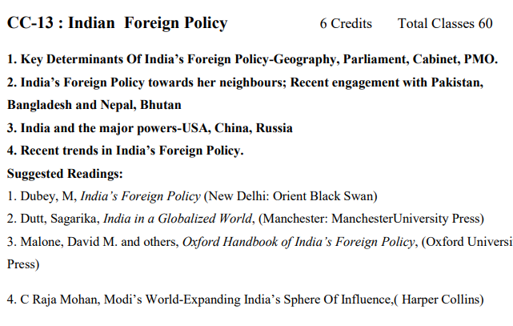

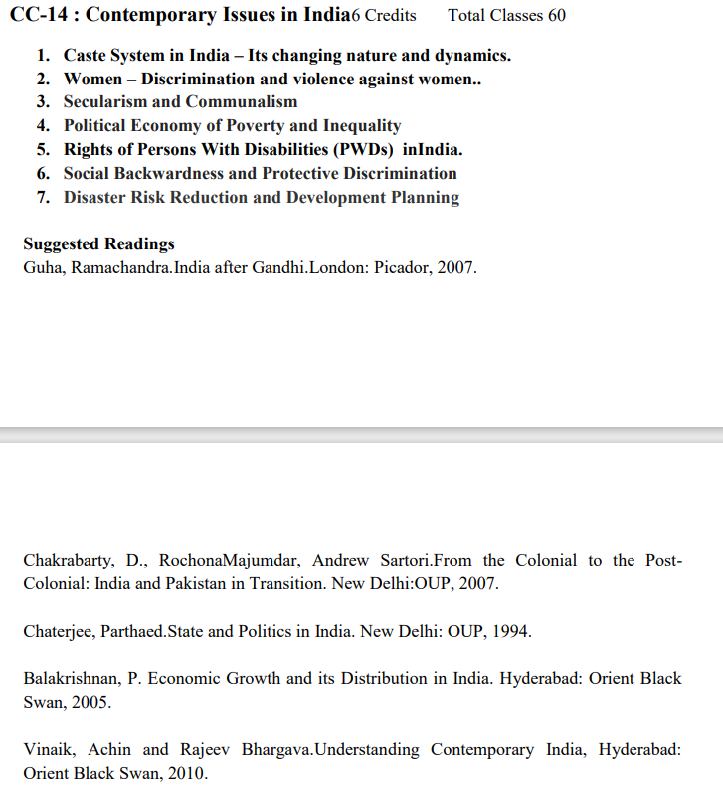

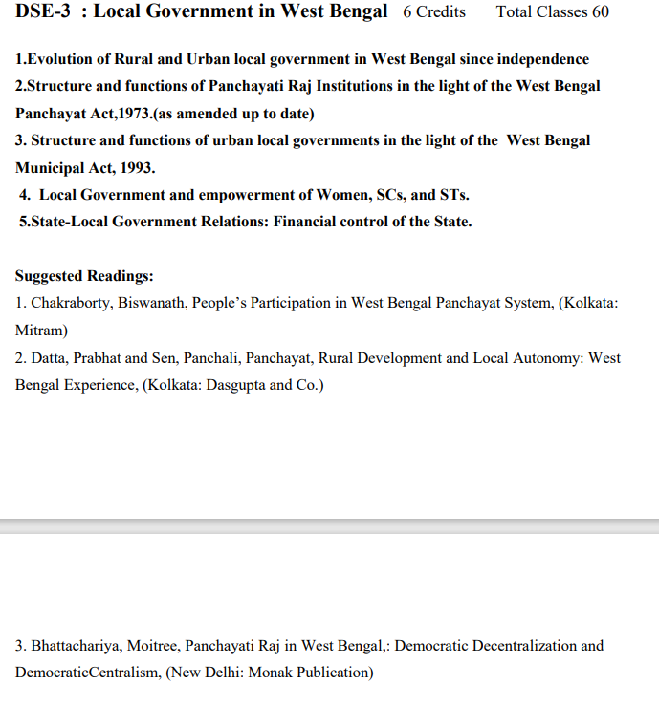

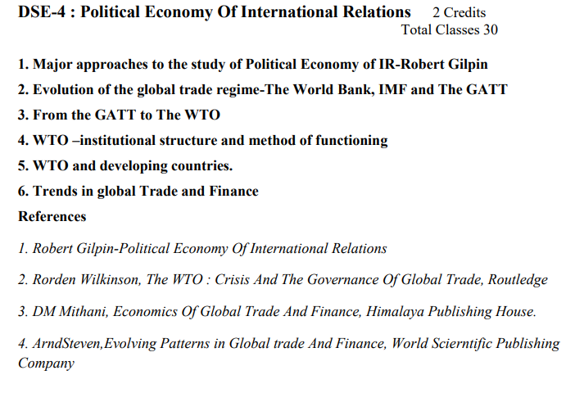

1. Key Determinants Of India’s Foreign Policy-Geography, Parliament, Cabinet, PMO.

2. India’s Foreign Policy towards her neighbors; Recent engagement with Pakistan, Bangladesh Nepal, Bhutan. 3. India and the major powers-USA, China, Russia. 4. Recent trends in India’s Foreign Policy.

|  |  |  |
| --- | --- | --- |
| PAPER | NAME OF THE TEACHER | TOPICS |
| CC-13:(Indian Foreign Policy) | TS | MODULE-17 |
| 1. Key Determinants of India’s Foreign Policy-Geography, Parliament, Cabinet, PMO.  2. India’s Foreign Policy towards her neighbors; Recent engagement with Pakistan, Bangladesh Nepal, and Bhutan.  3. India and the major powers-USA, China, Russia.  4. Recent trends in India’s Foreign Policy. |

|  |  |  |
| --- | --- | --- |
| PAPER | NAME OF THE TEACHER | TOPICS |
| CC-14: (Contemporary Issues in India) | BS | MODULE-18 |
| 1. Caste System in India – Its changing nature and dynamics.  2. Women – Discrimination and violence against women.  3. Secularism and Communalism. |
| NM | MODULE-19 |
| 4. Political Economy of Poverty and Inequality  5. Rights of Persons with Disabilities (PWDs) India.  6. Social Backwardness and Protective Discrimination  7. Disaster Risk Reduction and Development Planning |

|  |  |  |
| --- | --- | --- |
| PAPER | NAME OF THE TEACHER | TOPIC |
| DSE-3: (Local Government in West Bengal) | SMZ | MODULE-20 |
| 1. Evolution of Rural and Urban local government in West Bengal since independence  2. Structure and functions of Panchayati Raj Institutions in the light of the West Bengal Panchayat Act,1973. (as amended up to date).  3. Structure and functions of urban local governments in the light of the West Bengal  Municipal Act, 1993. |
| FU | MODULE-21 |
| 4. Local Government and empowerment of Women, SCs, and STs.  5. State-Local Government Relations: Financial control of the State. |

|  |  |  |
| --- | --- | --- |
| PAPER | NAME OF THE TEACHER | TOPICS |
| DSE-4: (Political Economy of International Relations) | TS | MODULE-22 |
| 1. Major approaches to the study of Political Economy of IR-Robert Gilpin  2. Evolution of the global trade regime-The World Bank, IMF, and the GATT.  3. From the GATT to the WTO.  4. WTO –institutional structure and method of functioning  5. WTO and developing countries.  6. Trends in Global Trade and Finance |



